Examine

<http://coop.apps.symfonycasts.com/>

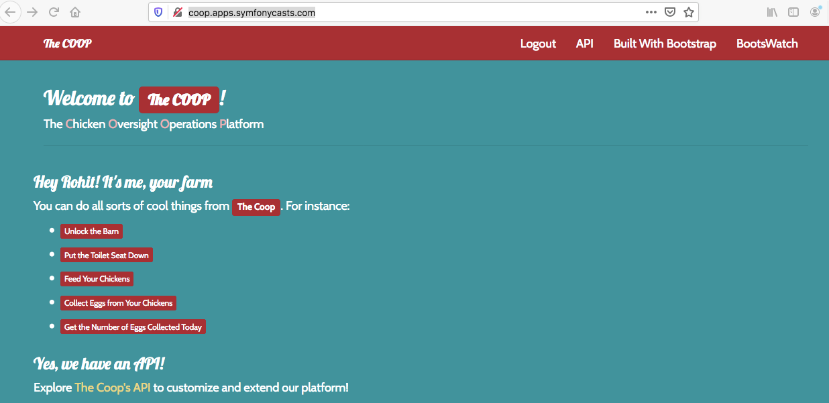

http://brentertainment.com/oauth2/

http://petstore.swagger.io/#/

rohitbh